

**SENSORS AND**

**AUTOMATION**

**Sarvesh Anand Mankar**

**142203013**

**SY Comp Div-2, S5 Batch**

**Practical-2: Characterization of Level Sensors**

**Aim:**

1. Review various methods of level measurement
2. Understand working of capacitance level transmitter

**Theory:**

**Level Measurements:**

In industry, liquids such as water, chemicals, and solvents are used in various processes. The amount of such liquid stored can be found by measuring level of the liquid in a container or vessel. The level affects not only the quantity delivered but also pressure and rate of flow in and out of the container. Level sensors detect the level of substances like liquids, slurries, granular materials, and powders. The substance to be measured can be inside a container or can be in its natural form (e.g. a river or a lake). The level measurement can be either continuous or point values.

**Continuous level sensors** measure the level to determine the exact amount of substance in a continuous manner.

**Point-level sensors** indicate whether the substance is above or below the sensing point. This is essential to avoid overflow or emptying of tanks and to protect pumps from dry run.

**Capacitance level sensors** are used for wide variety of solids, aqueous and organic liquids, and slurries. The technique is frequently referred as RF as radio frequency signals applied to the capacitance circuit. The sensors can be designed to sense material with dielectric constants as low as 1.1 (coke and fly ash) and as high as 88 (water) or more. Sludges and slurries such as dehydrated cake and sewage slurry (dielectric constant approx. 50) and liquid chemicals such as quicklime (dielectric constant approx. 90) can also be sensed. Dual-probe capacitance level sensors can also be used to sense the interface between two immiscible liquids with substantially different dielectric constants.

Since capacitance level sensors are electronic devices, phase modulation and the use of higher frequencies makes the sensor suitable for applications in which dielectric constants are similar.

**Working Principle:** The principle of capacitive level measurement is based on change of capacitance. An insulated electrode acts as one plate of capacitor and the tank wall (or reference electrode in a non-metallic vessel) acts as the other plate. The capacitance depends on the fluid level. An empty tank has a lower capacitance while a filled tank has a higher capacitance. A simple capacitor consists of two electrode plate separated by a small thickness of an insulator such as solid, liquid, gas, or vacuum. This insulator is also called as dielectric. Value of C depends on dielectric used, area of the plate and also distance between the plates.

C = E (K A/d)

Where: C = capacitance in picofarads (pF) E = a constant known as the absolute permittivity of free space K = relative dielectric constant of the insulating material A = effective area of the conductors d = distance between the conductors This change in capacitance can be measured using AC bridge.

**Pretest:**



**Selected Values:**

1. Height of tank: 1500cm
2. Outer radius: 2.5 cm
3. Inner Radius: 0.3 cm
4. Span Value: 1345 cm
5. Service: HCL

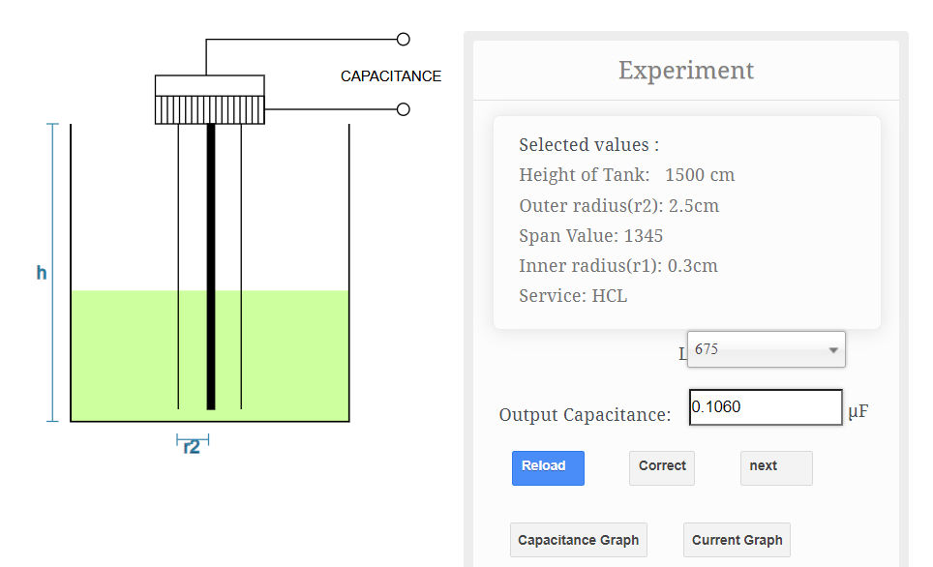

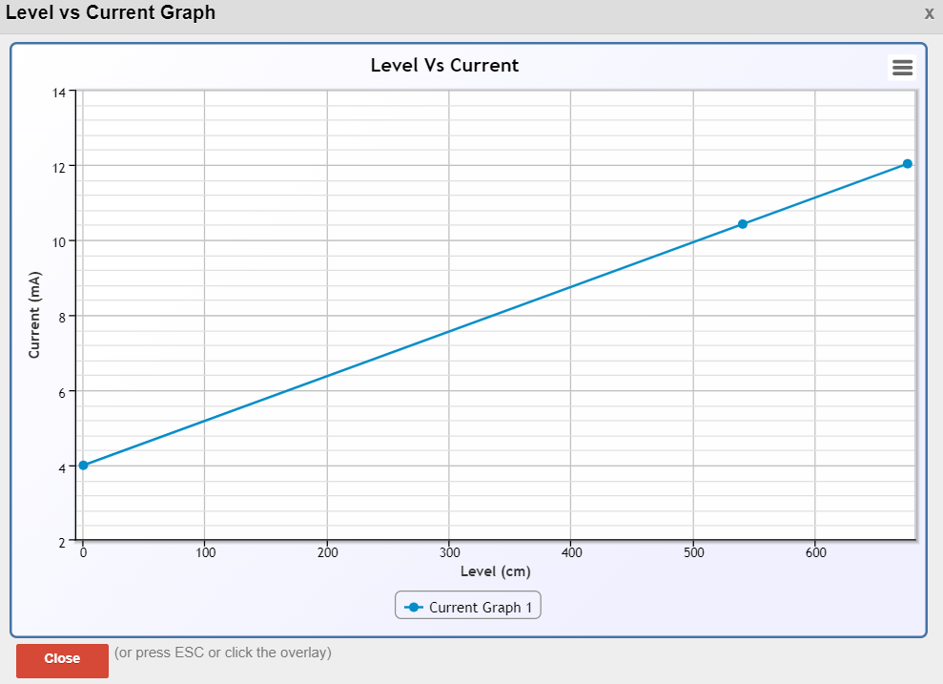

**Selected Values:**

1. Height of tank: 10000cm
2. Outer radius: 2.5 cm
3. Inner Radius: 0.1 cm
4. Span Value: 8995 cm
5. Service: Grain Of Mustered Seeds

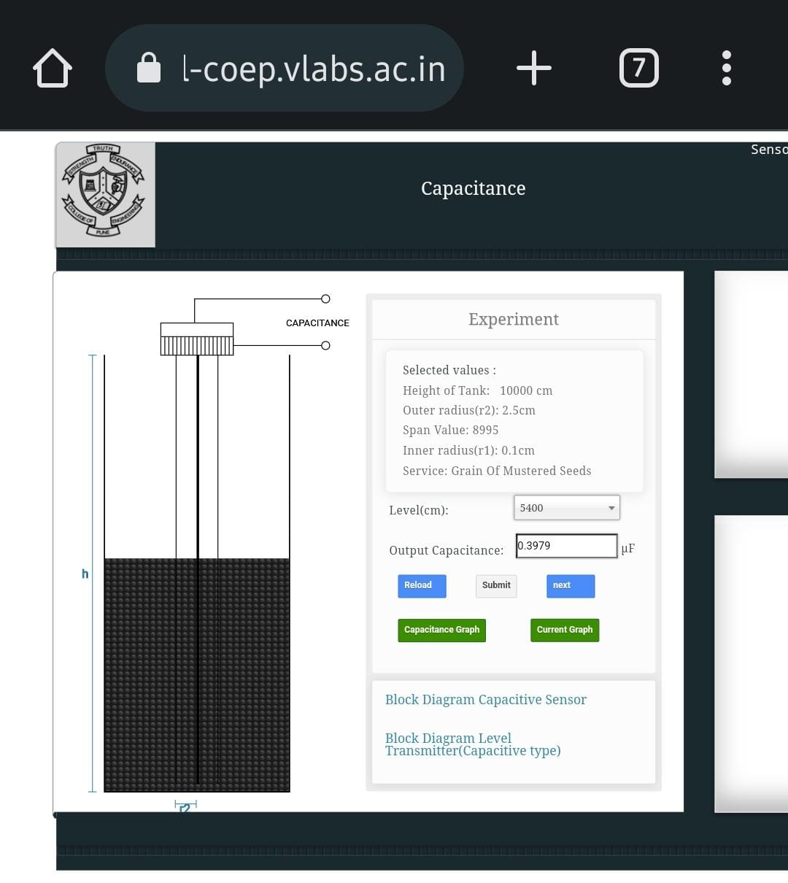

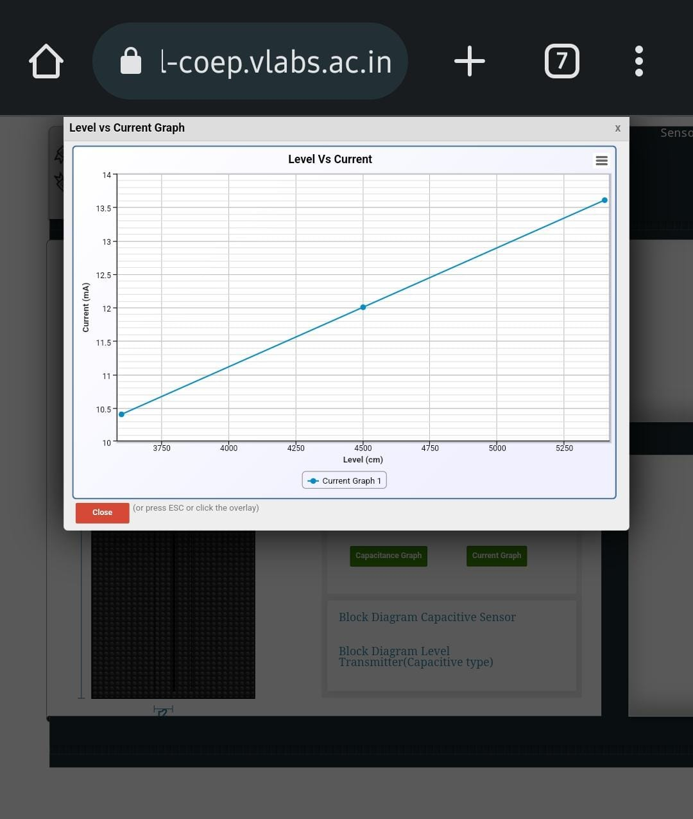

**Posttest:**

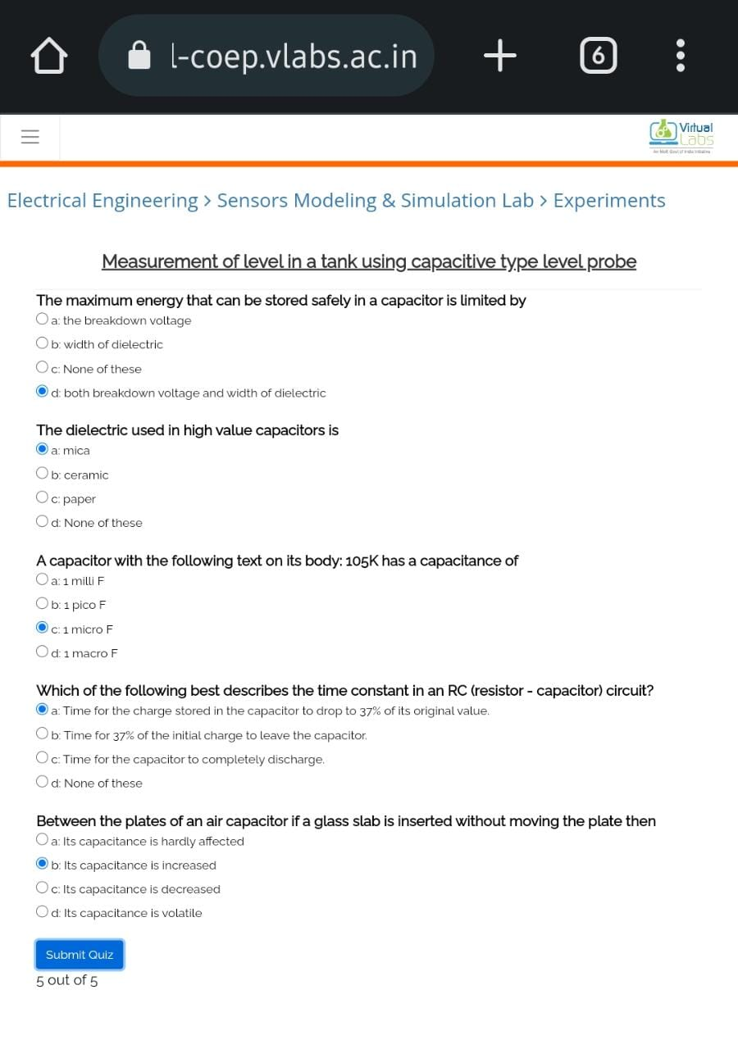

**Conclusion:**

We verified the measurement of level using capacitive principle by finding change in level by measuring change in capacitance.